**THEORETICAL FRAMEWORK**

In his book “The Presentation of Self in Everyday Life”, Ervin Goffman introduced the mechanisms of audience segregation. He describes how people play different roles in different situations. It is a mechanism wherein an individual perform roles, in order to create a favourable image of themselves and leave a good impression to others that is linked to the role they perform. The role that the individual performs is based on who their audience is.

Nowadays, more and more people are getting inclined to social networking sites because it provides an easier way for social interactions and communications. These sites allow user to share personal information about themselves through text, pictures, and other forms of media which in turn, creates an image for each user. However, the representation of oneself in the cyberspace is on a global scale in front of an audience which is possibly unknown and infinite. In social networking sites, the user’s privacy is threatened because a large audience might have access to his personal information. In order to handle privacy issues, there were few social media sites that offer limited options for making one’s profile visible for a specific set of individuals. As for some cases, audience segregation is used as a solution to protect user’s privacy. However, Goffman’s segregation of audiences is a lot harder in the era of the Internet. Difficulties begin when the audience is used to a certain type of performance from an individual or team but observes another performance which does not create the same impression which is falling to a cyberbullying. The impression created on a social networking profile may not resemble an individual’s real life identity.

The nature of communicating in the cyberspace facilitates the potential for anonymous interactions. It was discovered that bullies who choose to use electronic means can easily hide their real identity and make themselves anonymous. Anonymity can be created through the use of temporary email addresses, fictitious names when or using an unknown mobile number. The perception of anonymity in social media serves as a disinhibitor so that people are more likely to do and say things online that they would not do or say in a face to face situation. Another key characteristic of cyberbullying is the potential to reach a limitless audience. Due to the boundless nature of cyberspace, the audience is not confined to a single setting (such as school or office) but has the potential to be viewed by a global audience.

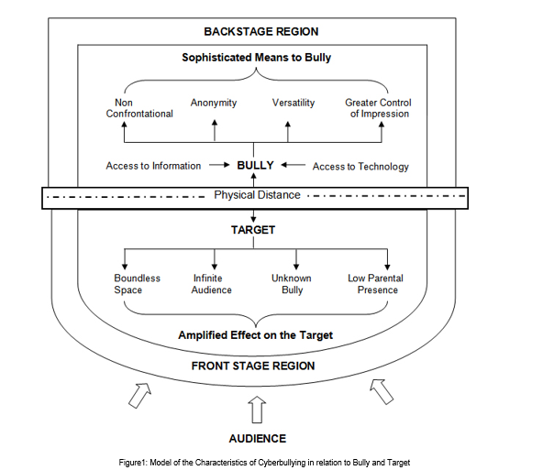

Goffman's framework offers not only a way of thinking about space in terms of performance but also a way of thinking about how people may act differently depending on the audience and setting which are relevant to an exploration of cyberbullying. Goffman defined three roles in this mechanism: performer, audience, and outsider. These roles can be paralleled to the roles of a target, bully and bystander. By framing bullying as a performance, a framework is provided that enables us to consider the bystander group as an audience and how different settings may affect how young people act towards others. In order to set the scene for a performance, Goffman made a distinction between the two regions of social space wherein an individual interacts. The front region is defined as the public performance area. The backstage region is a place wherein the performer can privately prepare for the performance or where members of a group can openly construct the impression they are planning to give. By using Goffman’s framework of performance, cyberspace interactions can be executed by the bully in the backstage region which impacts on the target in the public front stage region. As the backstage region is a place that performers may privately prepare away from the audience, this provides time and space for the bully to plan the ways in which they wish to target others. The physical distance which cyberspace interactions facilitate may also result in the bully managing the impression ‘given off’, the ability for the bully to conceal their identity and the tone and meaning being open to wider interpretation.